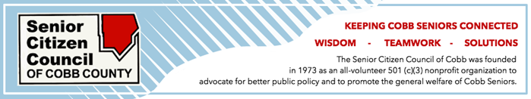

FOR IMMEDIATE RELEASE:
January 18, 2019
CONTACT: Linda Harris
(423) 815-1790
info@seniorcitizencouncilofcobb.org or lindageorgia@gmail.com

___________________________________________________________________________

THE SENIOR CITIZEN COUNCIL OF COBB ANNUAL MEETING WILL FEATURE
NEWLY ELECTED COUNTY COMMISSIONER KELI GAMBRILL AS GUEST SPEAKER

The Senior Citizen Council of Cobb County will feature newly elected District 1 Commissioner Keli Gambrill as guest speaker at their annual meeting on Friday, February 8, 2019. The meeting which starts at 11:30 am and includes a light lunch will be held at the Cobb County Senior Wellness Center at 1150 Powder Springs Street, Marietta.

All interested persons are welcome to attend free of charge to become acquainted with the new commissioner and to learn what the Senior Citizen Council has planned for 2019.
The Senior Citizen Council of Cobb is a nonprofit organization that advocates for better public policy and promotes ways for Cobb senior citizens to stay connected and engaged in their community.

Persons should RSVP before January 28 by calling 423.815.1790 or sending an email to
info@seniorcitizencouncilofcobb.org

(Please use photo of Keli Gambrill attached below)

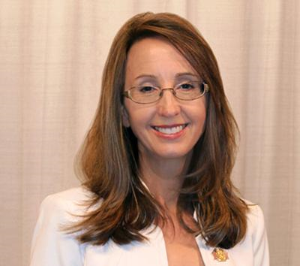

Keli Gambrill

Newly elected Cobb County District 1 Commissioner

