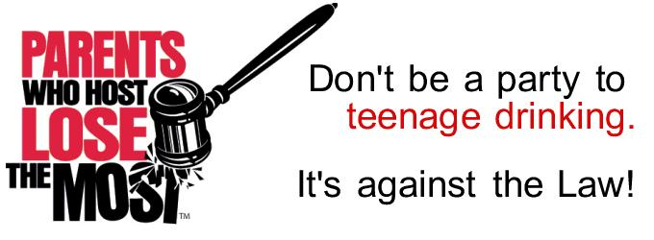

Clear. Consistent. Unified.

Parents Who Host, Lose the Most: Don’t Be a Party to Teenage Drinking- A campaign to educate parents about the health and safety risks of providing alcohol to teenagers and increases awareness of and compliance with underage drinking laws.

Jump on this bandwagon! The Cobb Community Alliance to Prevent Substance Abuse (CCAPSA) is working to prevent underage drinking in Cobb County by implementing the Parents Who Host, Lose the Most campaign. Alcohol remains the #1 drug of choice among youth. Underage alcohol use is often perceived as a rite of passage, but drinking alcohol can have lasting effects on the developing brain, such as:

- Reduction in cognitive function (memory, development of new brain cells, etc.)
- Impaired decision making
- Increased chances of engaging in risky behaviors
- Reduction in the brain’s white matter (responsible for communication between cells).

Most teens in Cobb County reported that they gain access to alcohol at home or a friend’s home. Fortunately, Cobb County takes teen drinking seriously and passed a Social Host Ordinance in 2012. This ordinance imposes a consequence on adults who allow underage drinking on their property. Demonstrate that your home is not a party to teenage drinking by pledging your support on CCAPSA’s website, www.ccapsa.org, and contact their Program Coordinator, Brittney Newton at 404-641-5462 or brittney@ccapsa.org for a FREE yard sign!

Social Media Post (You can tag us in posts on Facebook, using @CCAPSA2015)
Parents Who Host, Lose the Most: Don’t Be a Party to Teenage Drinking- A campaign to educate parents about the health and safety risks of providing alcohol to teenagers and increases awareness of and compliance with underage drinking laws.
Pledge your support at www.ccapsa.org!

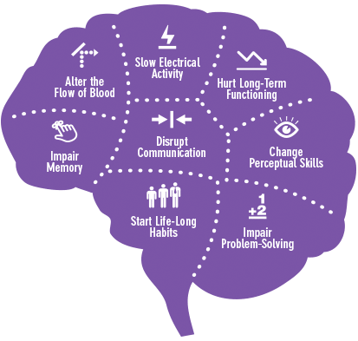
Underage alcohol use is not a rite of passage! Drinking alcohol can have lasting effects on the developing brain, such as:
- Reduction in cognitive function (memory, development of new brain cells, etc.)
- Impaired decision making
- Increased chances of engaging in risky behaviors
- Reduction in the brain’s white matter (responsible for communication between cells).

