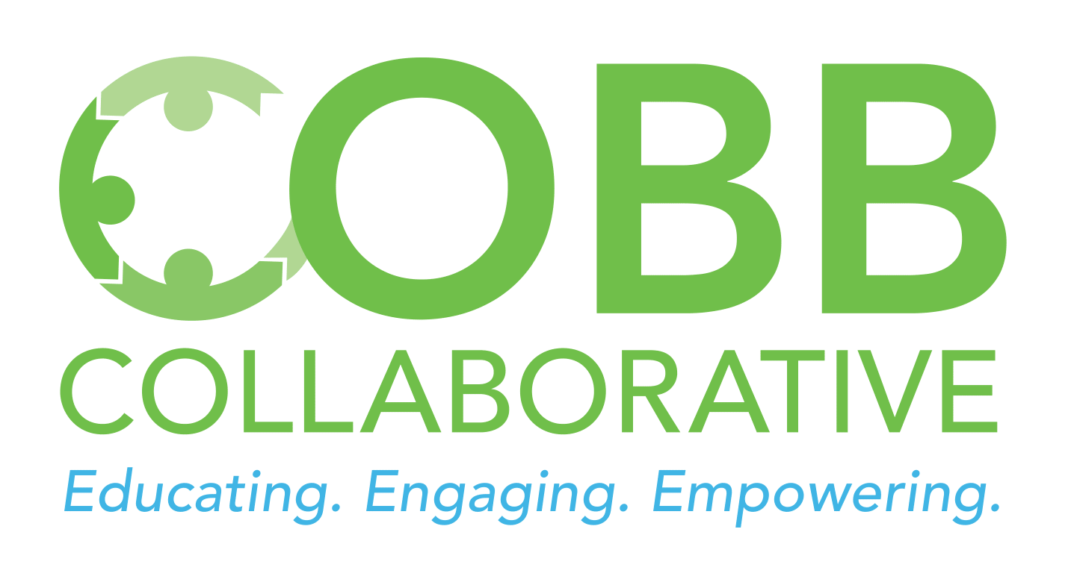
Cobb Collaborative, Inc. is committed to a diverse, inclusive, and equitable environment where all board members, staff, volunteers, and members feel respected and valued regardless of gender, age, race, ethnicity, religious beliefs, national origin, sexual orientation or identity, disability, education, or any other bias.

We are committed to being nondiscriminatory and providing equal opportunities for employment, volunteering, and advancement in all areas of our work.
We respect the value that diverse life experiences bring to our board and leadership and we strive to listen to their views and give them value.
We are committed to modeling diversity, inclusion, and equity and maintaining fair and equal treatment for all.
Our board’s philosophy to provide informed leadership for diversity, inclusion, and equity include:
- We will strive to see diversity, inclusion, and equity in connection with our vision and mission for the benefit of those we serve.
- We aim to recognize and address inequities in our policies, programs, and services.
- We will update and document progress on our diversity, equity, and inclusion practices.
- We commit to investigate underlying assumptions that interfere with our diversity policy.
- We commit to advocating for the elimination of systemic inequities that impact our work at the board level and address it according to this policy and in accordance with our mission.
- We commit to being transparent about diversity in all our interactions.
- We will dedicate our time and resources to expanding greater diversity within our board and leadership positions.
- We commit to leading with respect and tolerance and we encourage all employees and volunteers to express this in their work within our organization.
Cobb Collaborative, Inc. agrees to abide by the following action items to promote diversity, inclusion, and equity in our work:
- We will create new learning opportunities as we strive for cultural competency throughout our organization.
- We will strive to conduct or identify research related to equity so that we can make progress in the area of diversity, inclusion, and equity and we will share information through our communication channels.
- We will identify resources for our underrepresented constituents by networking with other organizations that are also committed to efforts for diversity, inclusion, and equity.
- We will train our personnel to be responsible for orienting, onboarding, and training our staff and volunteers on equitable practices.
- We will advocate for public and private policies in the public sector that promote diversity, inclusion, and equity and we will challenge systems and policies that describe inequity, disparity, and oppression.

