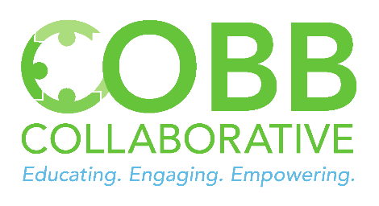
Irene M. Barton
Cobb Collaborative
ibarton@cobbcollaborative.org
678-766-5574

For immediate release September 12, 2022

“The more that you read, the more things you will know. The more that you learn, the more places you’ll go.” This well-known quote from author Dr. Suess was top of mind as community leaders and elected officials recently gathered to officially open a Little Free Library (LFL) at the Hugh L Grogan Jr. Community Center.
Little Free Library is a nonprofit organization dedicated to putting books in the hands of children and adults in communities around the world with a vision to have “a Little Free Library in every community and a book for every reader.” These book-sharing boxes remove barriers to book access by being available 24/7 with free accessibility. LFLs operate under the “Take One, Leave One” theory which encourages readers to not only take a book, but to leave one for others when there is an ability to do so.
A ribbon cutting was held for the Marietta Police Athletic League LFL on September 8. Marietta City Council members Cheryl Richardson, Johnny Walker, Carlyle Kent, and Joseph R. Goldstein joined Marietta PAL Executive Director Daneea Badio-McCray, PAL board members, youth participants and other leaders for the event. The LFL is in Ward 5 and Councilman Kent, who represents the area, expressed his enthusiasm that it would be a resource not only for the youth who are PAL members, but also the entire neighborhood. He stated that “Reading is the key to success in school and life.”
As a Little Free Library community partner, Cobb Collaborative has a goal of establishing LFLs throughout the county. Cobb Collaborative also serves as the local point of contact for the Get Georgia Reading Campaign. Research from the campaign demonstrates that development and use of language skills from childhood through adolescence can have a dramatic and positive impact on an individual’s quality of life and life outcomes.
The LFL at the community center is the 12th one dedicated this year with more planned for installation throughout the remainder of 2022. This one was made possible by a donation from a private fund managed by the Cobb Community Foundation.
For more information on Little Free Libraries, including sponsorship opportunities, please contact Cobb Collaborative Executive Director, Irene Barton, via email at ibarton@cobbcollaborative.org.

