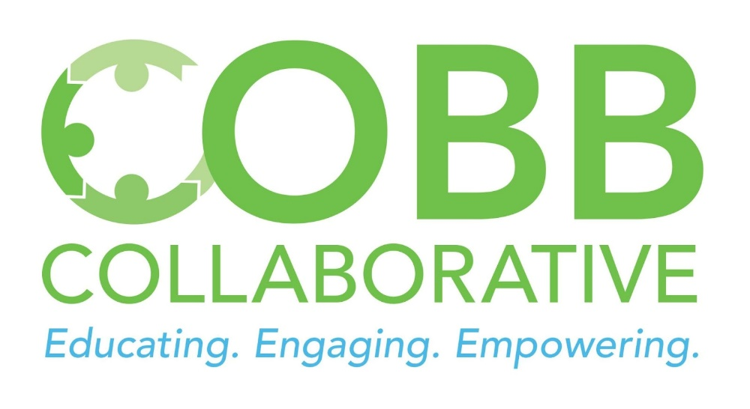

FOR IMMEDIATE RELEASE December 9, 2021
Media Contact:
Irene M. Barton, Executive Director
Cobb Collaborative
ibarton@cobbcollaborative.org
(678) 766-5574

28th Annual Cobb Collaborative
Human Services Awards

Smyrna, GA (December 9, 2021) – On December 8, 2021, the Cobb Collaborative (CC) hosted its 28th Annual Human Services Award Luncheon. With approximately 100 in attendance, the luncheon and awards ceremony took place at The Table in Smyrna and recognized nominees from local Cobb County nonprofit organizations.

Nominees were recognized for their dedication to working with or volunteering with those less fortunate in our community, professionalism within the community, collaboration with others and involvement in the community. The Collaborative awarded MUST Ministries’ volunteer Don Hausfeld with the volunteer award and Debbie Day, President & CEO of Special Needs Cobb, with the professional award. The William E. “Bill” Hanson Collaboration Award was presented to Shari B. Martin, President and CEO of the Cobb Community Foundation.

The six nominees in the volunteer category included Crystal Filiberto nominated by Atlanta Angels, William H. “Skip” Harper nominated by The Extension, Don Hausfeld nominated by MUST Ministries, Richard Pellegrino nominated by We Thrive in Riverside Renters Association, Carolynn Puffe nominated by Rescuing Hope and June VanBrackle nominated by Senior Citizen Council of Cobb County.

Professional nominees included Debbie Day nominated by Special Needs Cobb, Debbie Ginocchio nominated by Sweetwater Mission, Soumaya Khalifa nominated by Islamic Speakers Bureau of Atlanta, Jimmy Pace nominated by Marietta City Schools, and Angela Phelps nominated by MUST Ministries.

“We are excited and proud that so many individuals were recognized this year for their commitment and dedication to the great citizens of Cobb County,” stated Cobb Collaborative Executive Director Irene Barton. “We are a community blessed with people who care and care deeply about our neighbors. The hard work and commitment of professionals and volunteers throughout Cobb County create a safety net, a road out of poverty, and a brighter future for those who struggle in our community. The nominating organizations are representative of the enormous role that nonprofits play in taking care of individuals who are seeking to improve their current situation.”

The Jack Vaughan, Jr. Human Services Award was established in 1994 in memory of his unselfish dedication to public service. Jack Vaughan, Jr. was a state representative and member of the Cobb Collaborative who strongly advocated for those less fortunate in our community. In memory of Jack’s service, the Collaborative honors a volunteer and a professional who have gone above and beyond to serve those in need. Otis Brumby stated, "Vaughan always gave his best and what remains is the memory of an earnest young man eager to serve - one whose motto was selflessness, not selfishness."
The William E. (Bill) Hanson Collaboration Award was established in 2008 to honor Bill Hanson for his more than 25 years of service to Cobb County. He is recognized for his collaborative spirit and bringing the Cobb non-profit organizations together to tackle issues and concerns. Bill was one of the founders of the Cobb Human Services Coalition, a forerunner of the Cobb Collaborative and served in a variety of leadership positions with the CC. Each year Cobb Collaborative identifies a person or organization that represents the true meaning of collaboration. This year’s Bill Hanson Collaboration Award winner is Shari Martin, President and CEO of the Cobb Community Foundation. In March 2020, Cobb Community Foundation convened a cross-sector group of individuals to identify the most pressing issues of the day. Efforts were initiated and implemented to organize data and supply chain management approaches to scarce resources. Additionally, people and organizations were connected to encourage collaboration on working together to solve the pressing issues. Shari Martin was instrumental in the first round of funding from the county government being approved and continues to advocate for responsible investments from a variety of funders to this day.

The Cobb Collaborative staff and Board of Directors appreciate the support of event luncheon sponsor First Citizens Bank in Marietta. Additionally, Cobb Collaborative is grateful to Amy Crowell, author of The A-Z Guide to Event Fundraising, and founder of Next State Advisors, for sponsoring General Membership Meetings for 2021.

The Cobb Collaborative is a membership of non-profit organizations, local government, businesses, faith-based organizations, educational institutions, professional organizations, associations, and citizens who share ideas, expertise, and resources to meet the needs of Cobb County and its citizens.
###

